ASSIGNMENT-3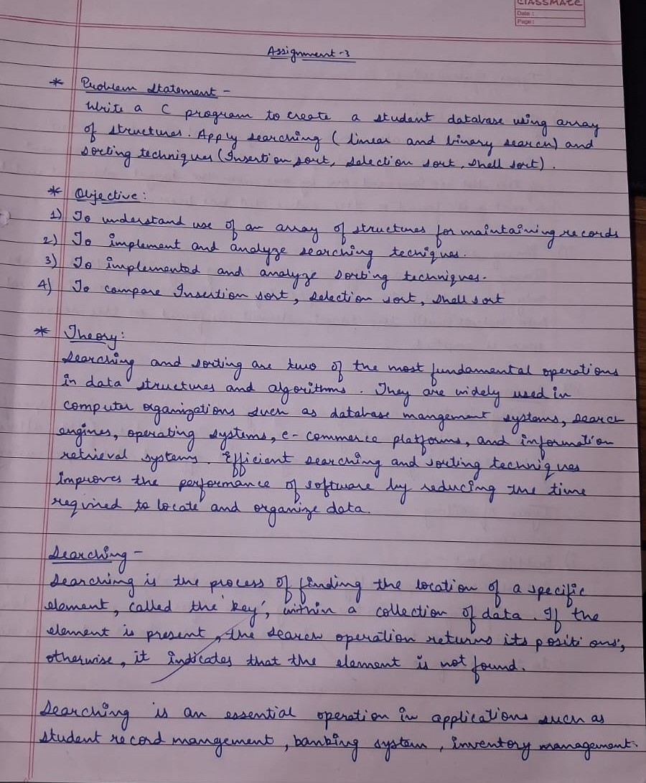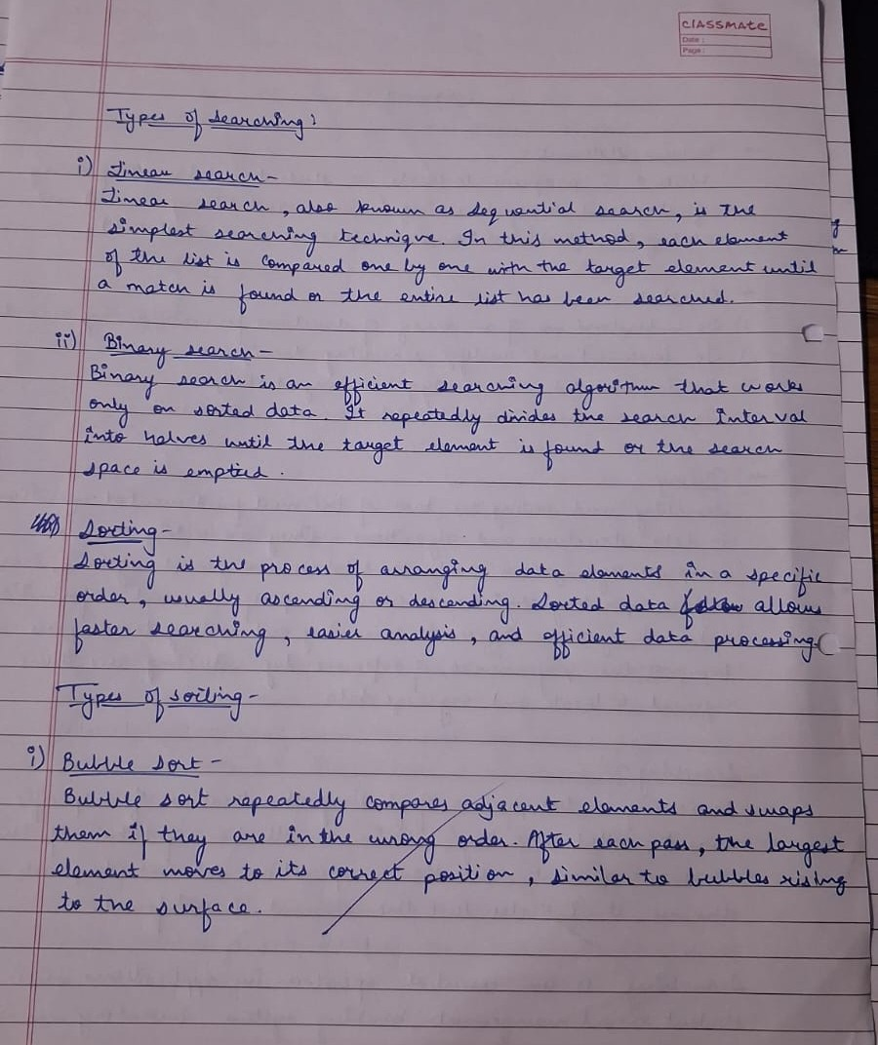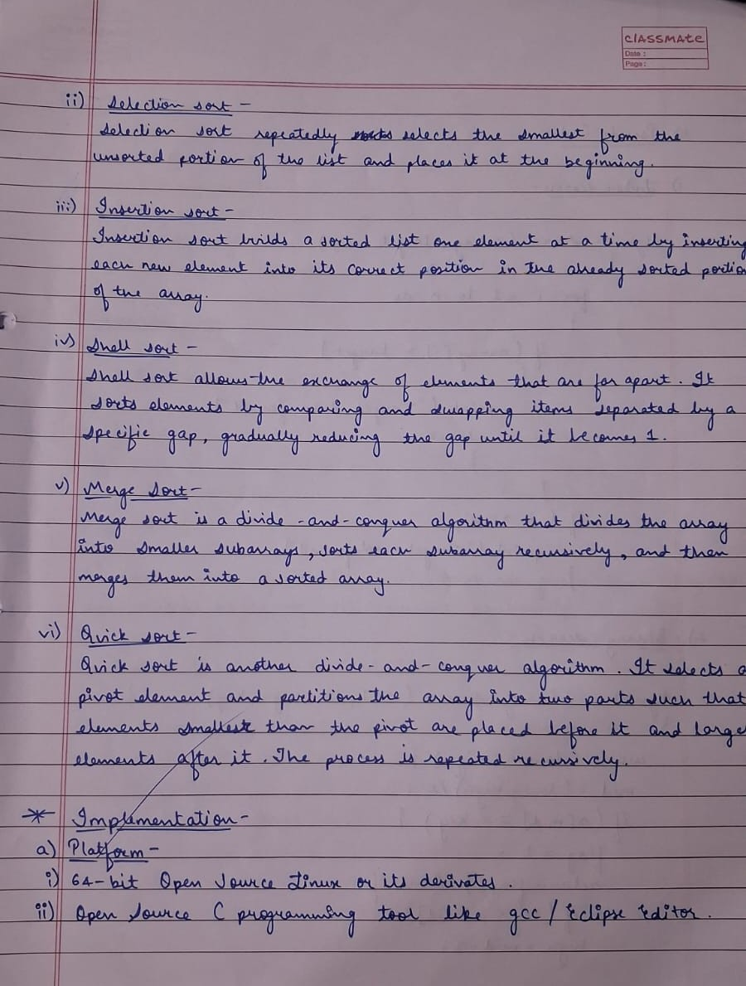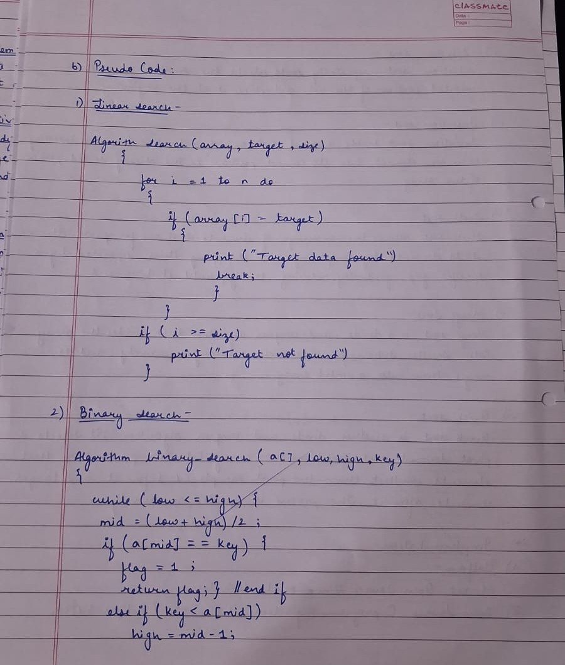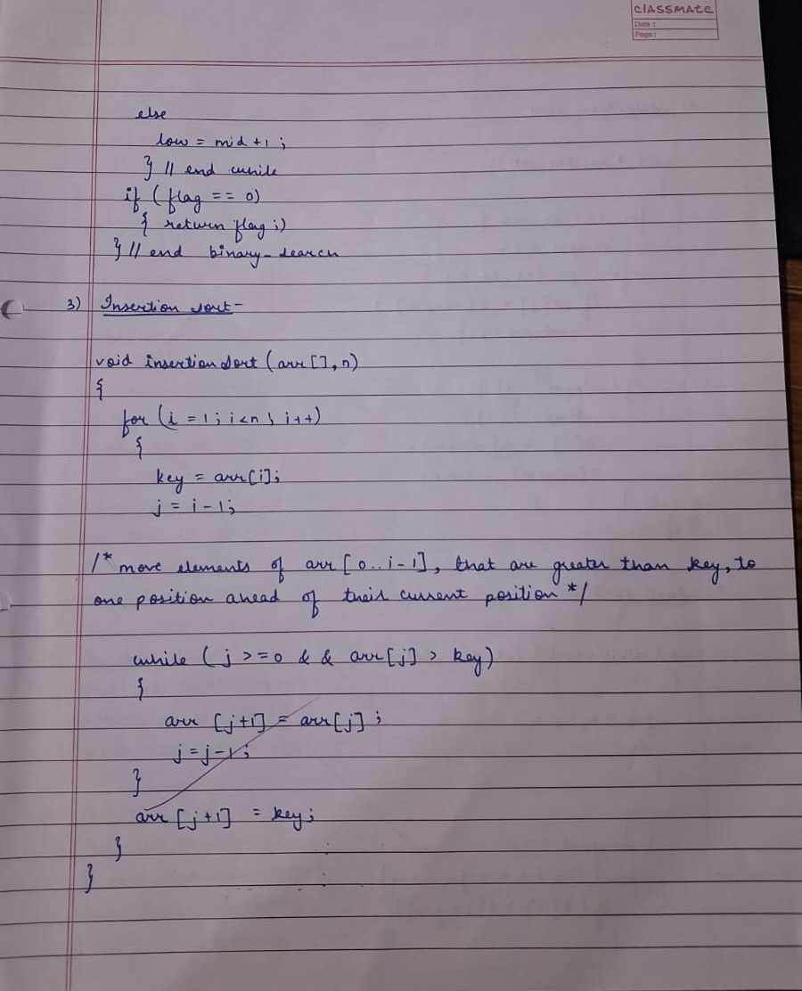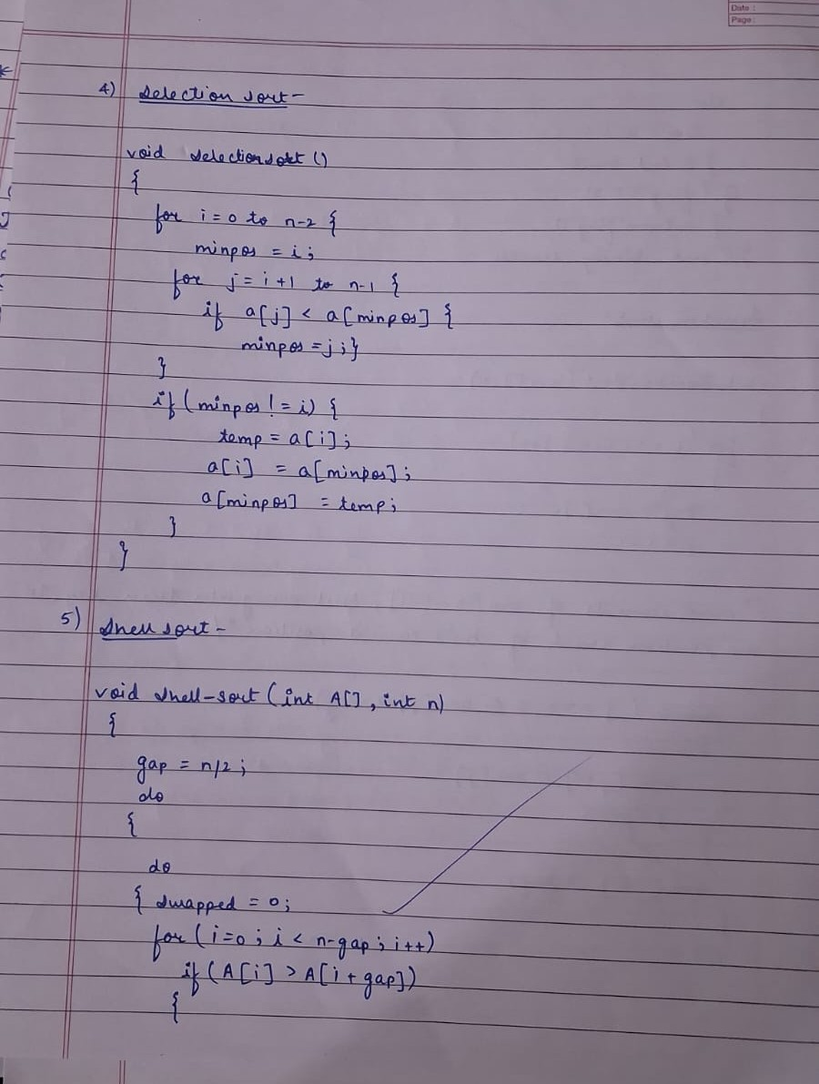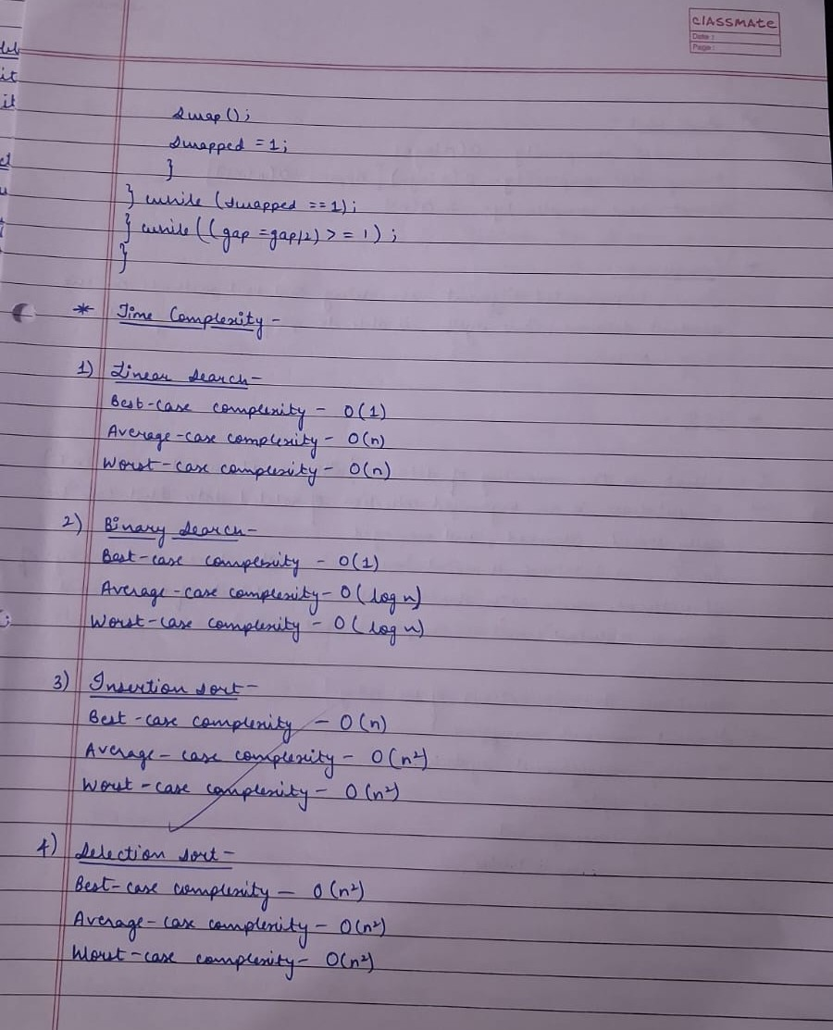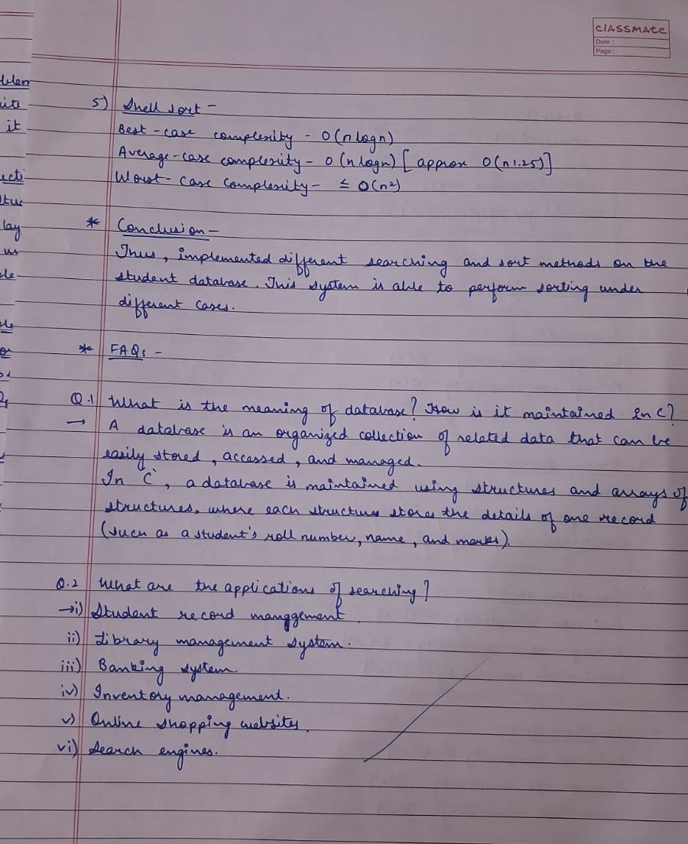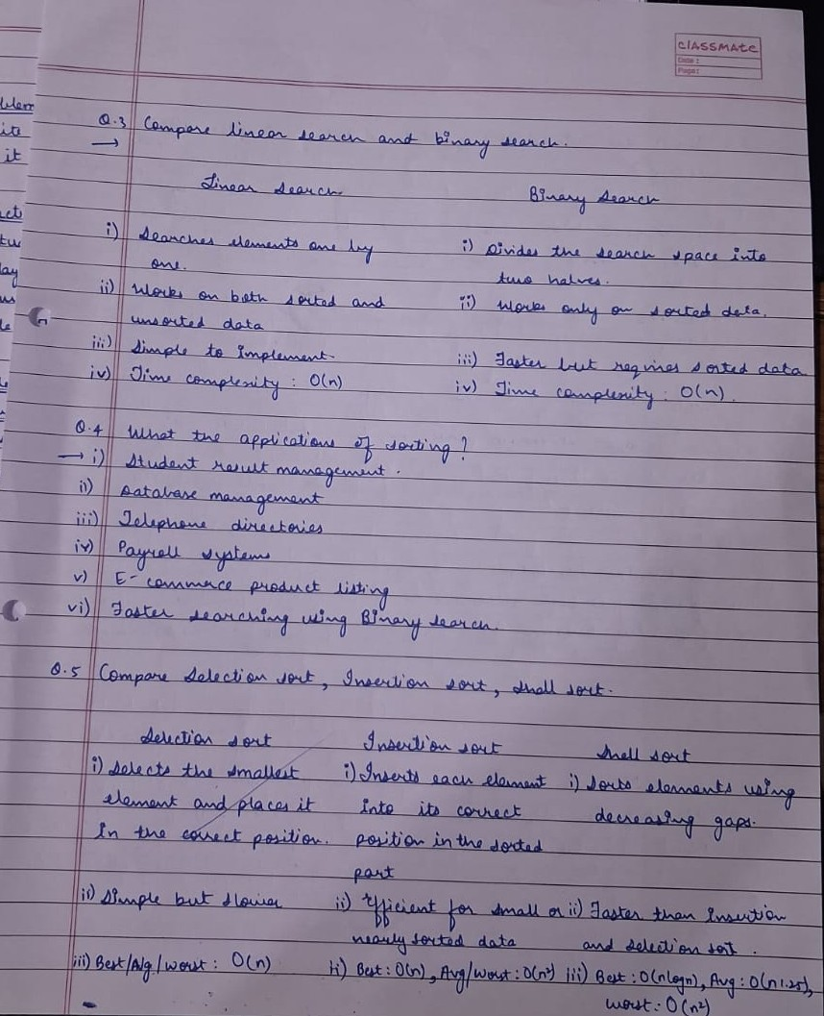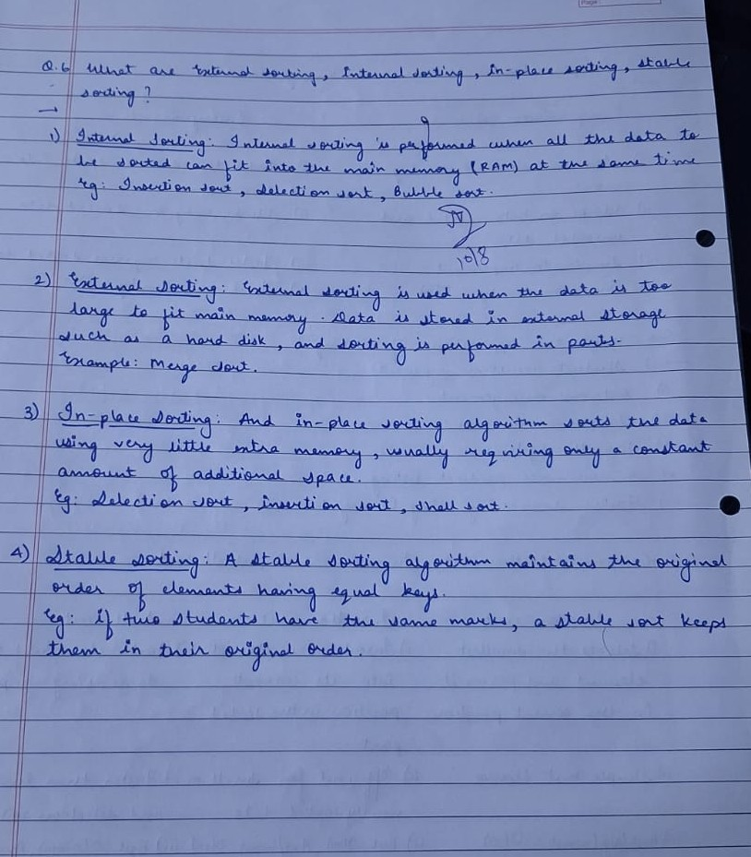

CODE:
#include <stdio.h>
#include <string.h>

#define MAX 100

struct Student
{
int rollNo;
char name[50];
float marks;
};

void displayDatabase(struct Student s[], int n);
int linearSearch(struct Student s[], int n, int target);
int binarySearch(struct Student s[], int n, int target);
void selectionSort(struct Student s[], int n);
void insertionSort(struct Student s[], int n);
void shellSort(struct Student s[], int n);

int main()
{
struct Student students[MAX];
int n = 0, choice, target, index;
int isSorted = 0;

printf("Enter the number of student records (minimum 5): ");
scanf("%d", &n);

while (n < 5)
{
printf("Please enter at least 5 records to satisfy test conditions: ");
scanf("%d", &n);
}

printf("\n--- Input Student Records ---\n");
for (int i = 0; i < n; i++)
{
printf("\nStudent %d:\n", i + 1);
printf("Roll Number: ");
scanf("%d", &students[i].rollNo);
printf("Name: ");
scanf(" %[^\n]s", students[i].name);
printf("Marks: ");
scanf("%f", &students[i].marks);
}

while (1)
{
printf("1. Display All Records\n");
printf("2. Linear Search (Unsorted/Sorted List)\n");
printf("3. Sort List using Selection Sort\n");
printf("4. Sort List using Insertion Sort\n");
printf("5. Sort List using Shell Sort\n");
printf("6. Binary Search (Sorted List Only)\n");
printf("7. Exit\n");
printf("Enter your choice (1-7): ");
scanf("%d", &choice);

switch (choice)
{
case 1:
displayDatabase(students, n);
break;

case 2:
printf("\n--- LINEAR SEARCH ---\n");
printf("Enter Roll Number to search: ");
scanf("%d", &target);
index = linearSearch(students, n, target);
if (index != -1)
{
printf("Record found at index %d!\n", index);
printf("Roll No: %d | Name: %s | Marks: %.2f\n", students[index].rollNo, students[index].name, students[index].marks);
}
else
{
printf("Student with Roll Number %d not found.\n", target);
}
break;

case 3:
printf("\n--- SELECTION SORT ---\n");
selectionSort(students, n);
isSorted = 1;
printf("\nList sorted successfully by Roll Call order!\n");
displayDatabase(students, n);
break;

case 4:
printf("\n--- INSERTION SORT ---\n");
insertionSort(students, n);
isSorted = 1;
printf("\nList sorted successfully by Roll Call order!\n");
displayDatabase(students, n);
break;

case 5:
printf("\n--- SHELL SORT ---\n");
shellSort(students, n);
isSorted = 1;
printf("\nList sorted successfully by Roll Call order!\n");
displayDatabase(students, n);
break;

case 6:
printf("\n--- BINARY SEARCH ---\n");
if (!isSorted)
{
printf("List is not sorted! Auto-sorting using Insertion Sort first...\n");
insertionSort(students, n);
isSorted = 1;
}
printf("Enter Roll Number to search: ");
scanf("%d", &target);
index = binarySearch(students, n, target);
if (index != -1)
{
printf("Record found at index %d!\n", index);
printf("Roll No: %d | Name: %s | Marks: %.2f\n", students[index].rollNo, students[index].name, students[index].marks);
}
else
{
printf("Student with Roll Number %d not found.\n", target);
}
break;

case 7:
printf("\nExiting program... Good bye!\n");
return 0;

default:
printf("Invalid choice! Please select between 1 and 7.\n");
}
}
return 0;
}

void displayDatabase(struct Student s[], int n)
{
printf("%-10s %-25s %-10s\n", "Roll No", "Name", "Marks");
for (int i = 0; i < n; i++)
{
printf("%-10d %-25s %-10.2f\n", s[i].rollNo, s[i].name, s[i].marks);
}
}

int linearSearch(struct Student s[], int n, int target)
{
int comparisons = 0;
for (int i = 0; i < n; i++)
{
comparisons++;
if (s[i].rollNo == target)
{
printf("[Analysis] Total Comparisons made: %d\n", comparisons);
return i;
}
}
printf("[Analysis] Total Comparisons made: %d\n", comparisons);
return -1;
}

int binarySearch(struct Student s[], int n, int target)
{
int low = 0, high = n - 1, mid;
int comparisons = 0;

while (low <= high)
{
comparisons++;
mid = low + (high - low) / 2;

if (s[mid].rollNo == target)
{
printf("[Analysis] Total Comparisons made: %d\n", comparisons);
return mid;
}
if (s[mid].rollNo < target)
{
low = mid + 1;
}
else
{
high = mid - 1;
}
}
printf("[Analysis] Total Comparisons made: %d\n", comparisons);
return -1;
}

void selectionSort(struct Student s[], int n)
{
int comparisons = 0, swaps = 0;
for (int i = 0; i < n - 1; i++)
{
int minIdx = i;
for (int j = i + 1; j < n; j++)
{
comparisons++;
if (s[j].rollNo < s[minIdx].rollNo)
{
minIdx = j;
}
}
if (minIdx != i)
{
struct Student temp = s[i];
s[i] = s[minIdx];
s[minIdx] = temp;
swaps++;
}
}
printf("[Analysis] Selection Sort completed with %d Comparisons and %d Swaps.\n", comparisons, swaps);
}

void insertionSort(struct Student s[], int n)
{
int comparisons = 0, shifts = 0;
for (int i = 1; i < n; i++)
{
struct Student key = s[i];
int j = i - 1;

while (j >= 0 && s[j].rollNo > key.rollNo)
{
comparisons++;
s[j + 1] = s[j];
j--;
shifts++;
}
if (j >= 0) comparisons++;
s[j + 1] = key;
}
printf("[Analysis] Insertion Sort completed with ~%d Comparisons and %d Shifts.\n", comparisons, shifts);
}

void shellSort(struct Student s[], int n)
{
int comparisons = 0, swaps = 0;
for (int gap = n / 2; gap > 0; gap /= 2)
{
for (int i = gap; i < n; i++)
{
struct Student temp = s[i];
int j;
for (j = i; j >= gap && s[j - gap].rollNo > temp.rollNo; j -= gap)
{
comparisons++;
s[j] = s[j - gap];
swaps++;
}
if (j >= gap) comparisons++;
s[j] = temp;
}
}
printf("[Analysis] Shell Sort completed with ~%d Comparisons and %d Swaps/Shifts.\n", comparisons, swaps);
}

OUTPUT:
